G. Rupa Manasa 13-12-2023

Day 9 Assessment

**Python if statement**

The if statement evaluates condition.

If condition is evaluated to True, the code inside the body of if is executed.

If condition is evaluated to False, the code inside the body of if is skipped.

**Syntax:**

if condition:

# body of if statement

**Example:**

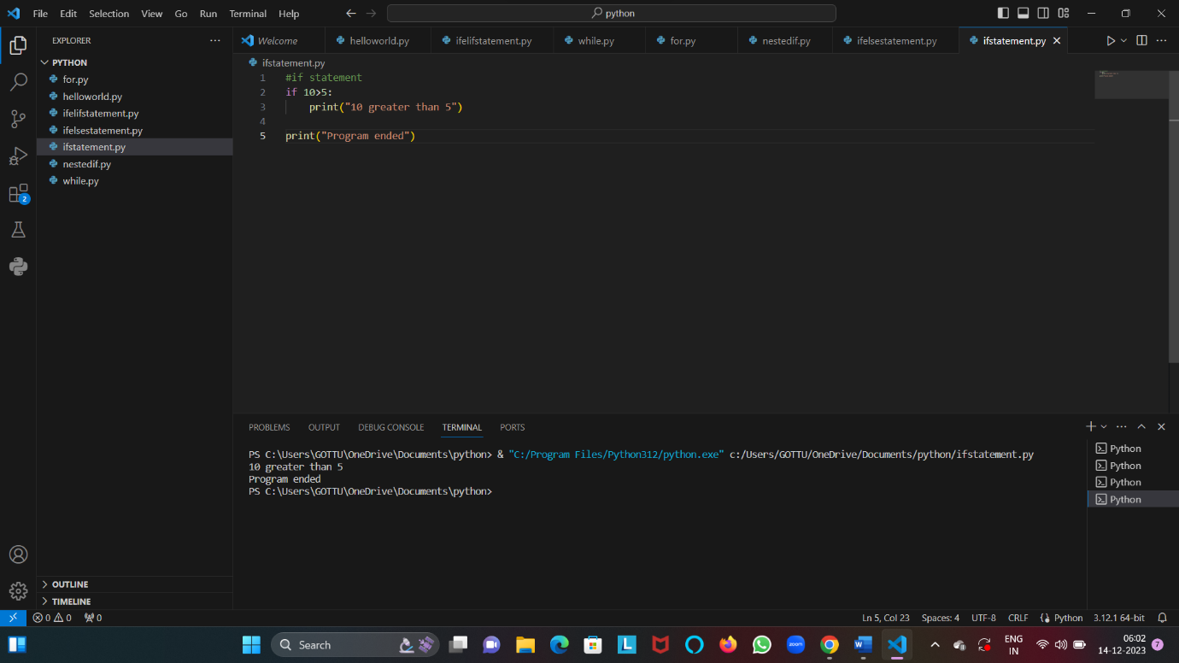

**If else statement**

The if...else statement evaluates the given condition:

If the condition evaluates to True, the code inside if is executed and the code inside else is skipped.

If the condition evaluates to False, the code inside else is executed and the code inside if is skipped.

**Syntax:**

if condition:

# block of code if condition is True

else:

# block of code if condition is False

**Example:**

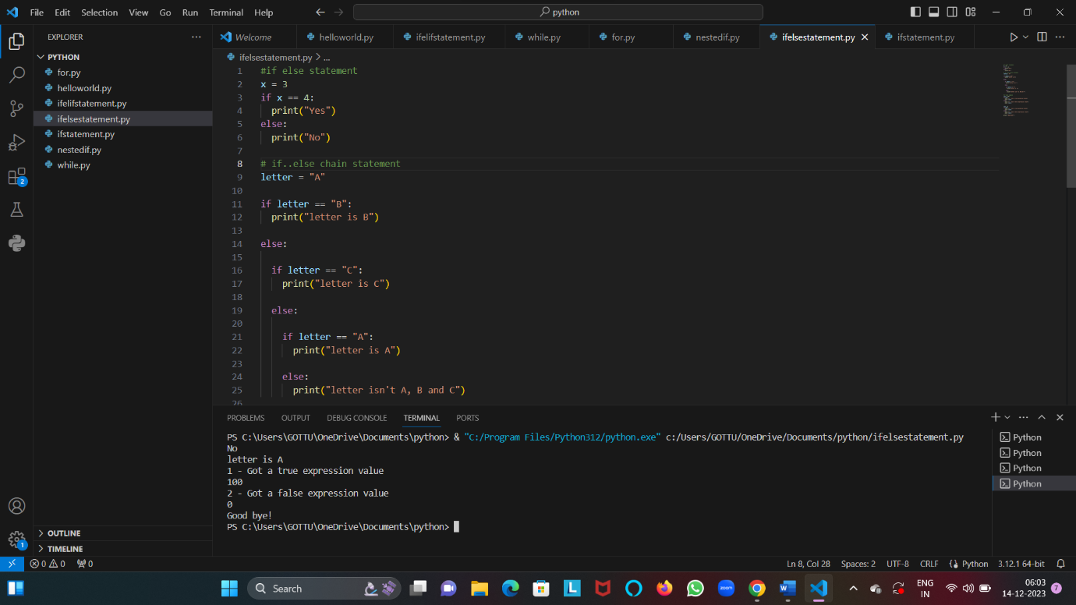

**Nested If statement**

We can also use an if statement inside of an if statement. This is known as a nested if statement. This means that inner if condition will be checked only if outer if condition is true.

**Syntax:**

# outer if statement

if condition1:

# statement(s)

# inner if statement

if condition2:

# statement(s)

**Example:**

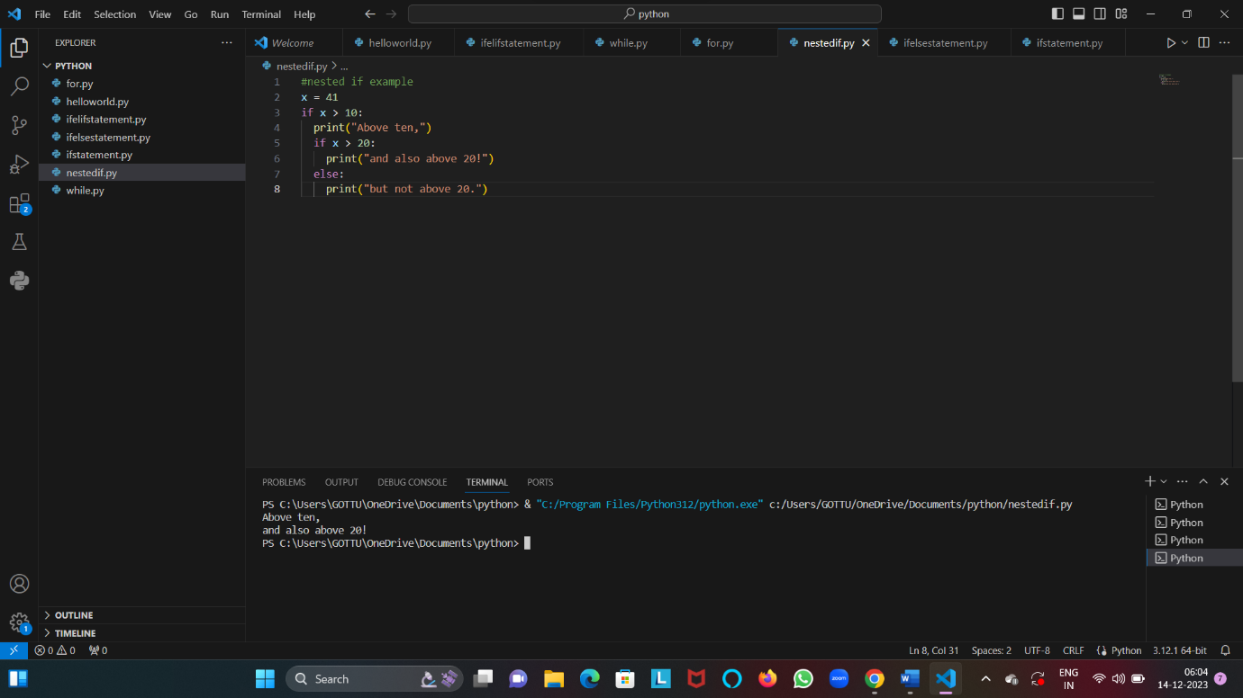

**If-elif statement**

The if-elif statement is shortcut of if..else chain. While using if-elif statement at the end else block is added which is performed if none of the above if-elif statement is true.

**Syntax:**

if (condition):

statement

elif (condition):

statement

.

.

.

.

else:

statement

**Example:**

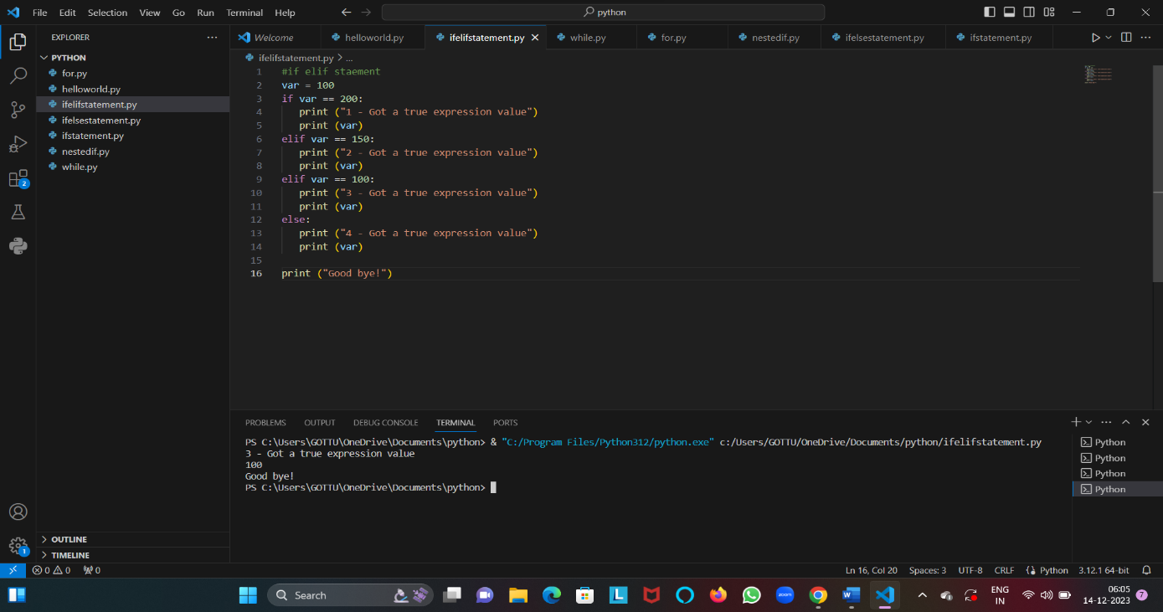

**Loops in Python**

**While loop**

While loop is used to execute a block of statements repeatedly until a given condition is satisfied. And when the condition becomes false, the line immediately after the loop in the program is executed.

**Syntax:**

while expression:

statement(s)

**Using else statement with While Loop**

The else clause is only executed when your while condition becomes false. If you break out of the loop, or if an exception is raised, it won’t be executed.

**Syntax of While Loop with else statement:**

while condition:

# execute these statements

else:

# execute these statements

**Example:**

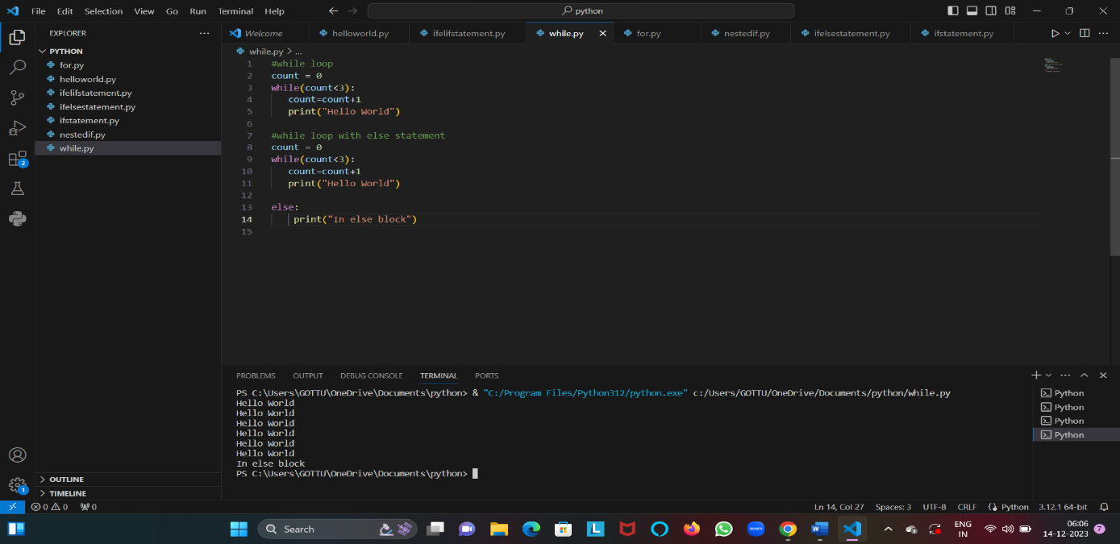

**For loop**

For loop is used to iterate over sequences such as lists, tuples, string, etc.

**Syntax:**

for val in sequence:

# statement(s)

**Example:**

